**HTML – BODY (headings and para)**

**HTML Tutorial: Headings & Paragraphs | Web Development Tutorials #5**

In the last section, we have discussed the head tags. Therefore, in this HTML tutorial, we will see the basics of **<body>**tag. Since this course is for both beginners and advanced, therefore, we will learn each and every basic topic.  Some students were still having trouble in understanding what *Emmet Abbreviation* is*.*[*Emmet abbreviation*](https://docs.emmet.io/abbreviations/#:~:text=Abbreviations%20are%20the%20heart%20of,knows%20how%20to%20use%20it.) just makes our work easy providing us the basic template of HTML. Abbreviations are the heart of the Emmet toolkit. It comes automatically built-in with Visual Studio Code.Let us begin with the simple **heading** tags. There are basically six types of heading tags ranging from ***<h1>, <h2>, <h3>, <h4>, <h5>, and <h6>.***These are the six heading tags from h1 being the largest font size and h6 being the smallest font size. There is an important you should know about **H1**tags. In every website there is only one **<h1>**tag, which is the main heading of the website. You should never write the normal paragraph text as headings just to make it bold. It is advised that using <h1> tag **only once** will help in SEO (Search Engine Optimization) of a website and even ranking it higher in different search engines.

Then comes the paragraph tag which is denoted by **<p>.** Whenever we want to add a paragraph on our website then we can simply use paragraph tag in the format-

<p>some random texts</p>

Copy

To write a new paragraph, simply jump on a new line and start writing the new paragraph in a paragraph tag. To get 4 different lines of paragrapgh tag, we can simply write ***p*4.***

Let us now discuss the main advantage of emmet abbreviation. If we want some random texts up to any number of words then we can either copy from any article from the Internet or just write random words, which of course will not look good. To avoid this, we can write ***lorem*** and the number of words we want in a paragraph. Let us understand with an example-

<p>Lorem40</p>

Copy

This code will give us a paragraph of 40 words.

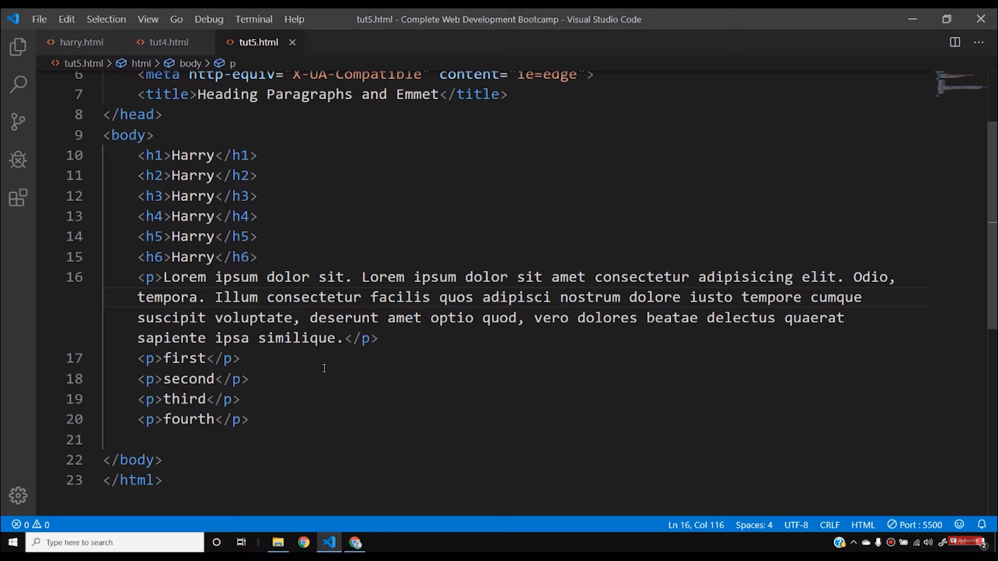

The next tags that we are going to see are **<strong>**and **<em>**(emphasized) tags. Writing some texts between *strong*tags will make that portion of the text as bold. And writing any text between *em*tags, will convert that part as Italic. However, these texts can later be changed with the help of CSS.

Now to change a line in a paragraph we can easily use the **<br>**tag. It is a self-closing tag which helps to break a line. However, using too many <br> tags is not good for practice. We will discuss this more when we are going to learn CSS.

<p>first<br><br><br><br>This is a new line</p>

Copy

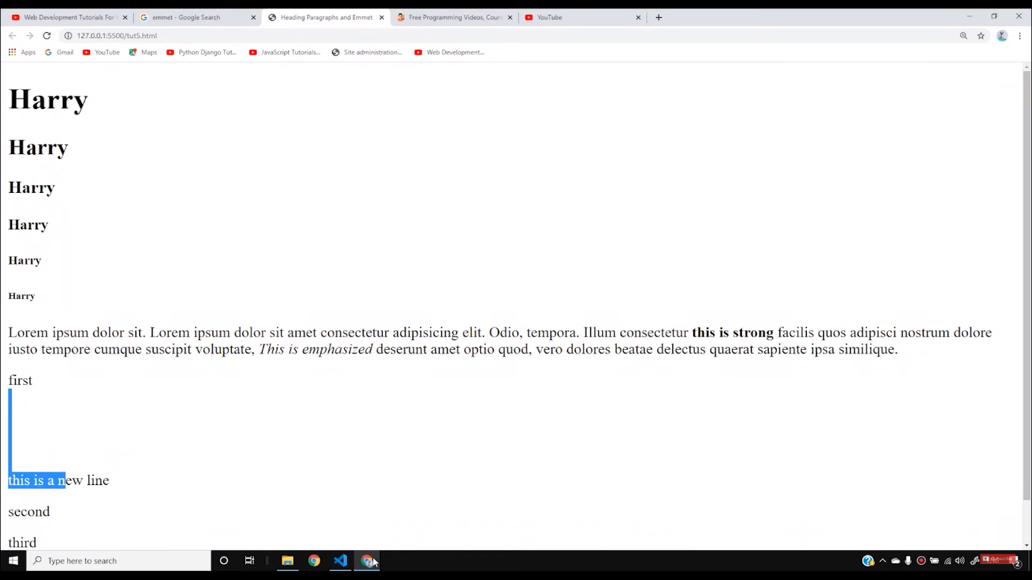

Then the next tag is the **<hr>**tag which is also a self-closing tag. It helps to add a horizontal ruler like a line on the webpage. Apart from these there are also **Bold**and **Italic**tags also but it is is recommened to use them in HTML 5. It is recommended to use **strong** and **em** tags instead.

In the beginning, you may think, our websites are looking a little ugly but when we will go to the CSS section then, believe me, our website will start looking more attractive like other professional websites. So stay tuned with the tutorials to get more knowledge about the complete web development course.

**Code as described/written in the video**

<!DOCTYPE html>

<html lang="en">

<head>

<meta charset="UTF-8">

<meta name="viewport" content="width=device-width, initial-scale=1.0">

<meta http-equiv="X-UA-Compatible" content="ie=edge">

<meta name="description" content="This is description">

<meta name="keywords" content="html, html tutorials, web development">

<meta name="robots" content="INDEX, FOLLOW">

<title>Document</title>

<!-- This is how you include external css -->

<link rel="stylesheet" href="harry.css">

<!-- This is how you include external JavaScript -->

<script src="harry.js"></script>

</head>

<body>

</body>

</html>